Work Instructions (WI) of Cab Camera

Project Name: EF9K

Project Number: P232302009

Contract Number: LOI dated 08.01.2024

Document Number: P232302009_Work_Instruction_CVVRS_CC_V1.00

Module Name: Crew Voice and Video Recording System

Edition: | Revision History: | Owner: | Reviewer: | Approver:
1.00 | First Release | Gaurav Purohit  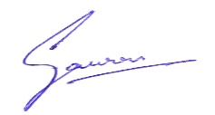  25.11.2024 | 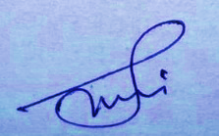  Saurabh Tyagi  28.11.2024 | 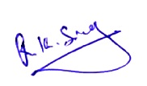  Rakesh Kumar Singh  30.11.2024

All information in this document is subject to change without notice. No part of this document may be reproduced or transmitted in any form or by any means, electronic or mechanical, for any purpose, without the express written permission of PTCS.
Contents
1 5S 3
2 Safety Cautions 4
3 Tools Required 5
4 Special Processes 6
5 Base plate assembly 6
5.1 Grommet Fitting 6
5.2 Cable Preparation 7
5.3 Cable fitment in base plate 8
5.4 Prepare a shield wire 9
5.5 Fix the sealing ring 9
5.6 Epoxy process 10
5.7 Connection of 6-Pin Data connector 11
5.8 Conformal Instructions 11
5.9 Place thermal conductive sheet 12
5.10 Motherboard PCB fitment 13
5.11 PoE & Shield wire Connections 14
6 Middle/Internal assembly 16
6.1 Lens Ball assembly (260.2274.00) 16
6.2 Microphone (165.0009.00) assembly (For with Mic cameras only) 17
6.3 Inner shell assembly 18
6.3.1 Lens ball assembly and inner shell cover fitment 18
6.3.2 Safety Rope and Desiccant 20
6.3.3 Wiring Connection’s Description 21
6.4 Fitment of Middle/Inner Assembly 22
7 Final Assembly 24
8 Annexures 24

5S

- Sort
- Set in order
- Shine
- Standardize
- Sustain

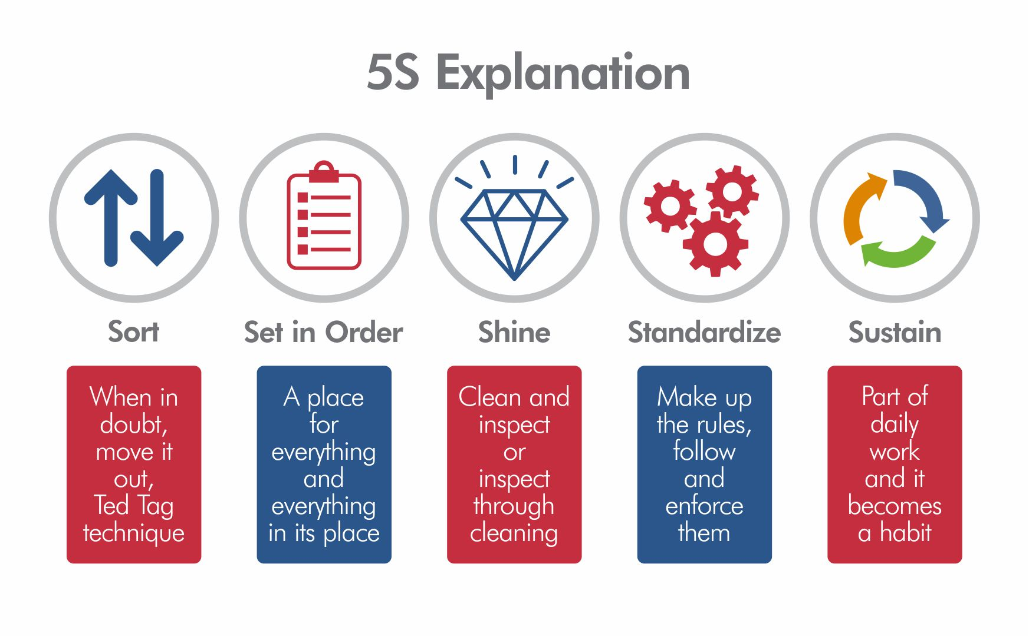

Safety Cautions

- Area and Personnel must be ESD protected.
- Product is fragile handle with care.
- Area must be dust free.
- Always wear ESD Gloves during the process.
- Always wear ESD wrist band during the process.
- Do not drink any types of solution to be use in bonding and conformal processes.

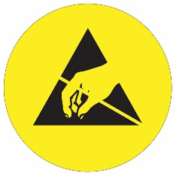

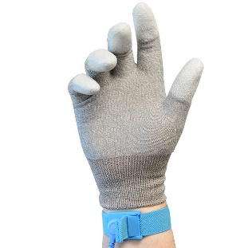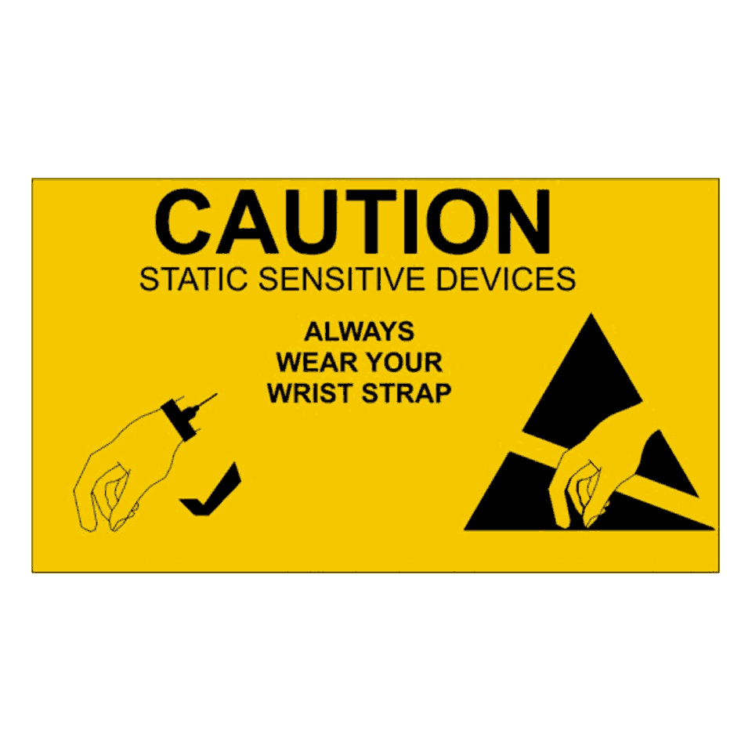

Tools Required

- Screw driver
- Hex Spanner
- Wire Cutter
- Soldering Station
- Torx Allen key (T10)
- Disposable Syringe
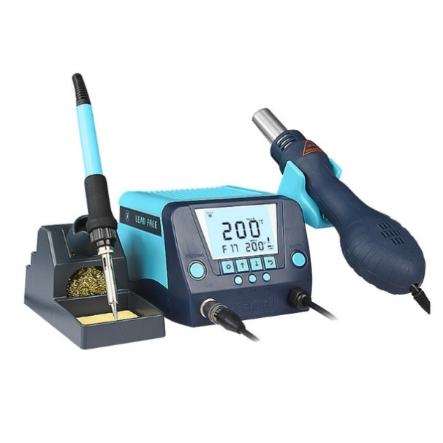
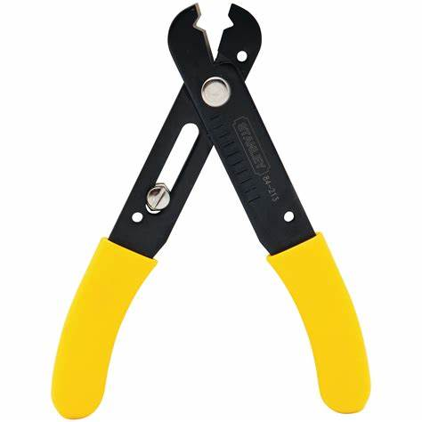
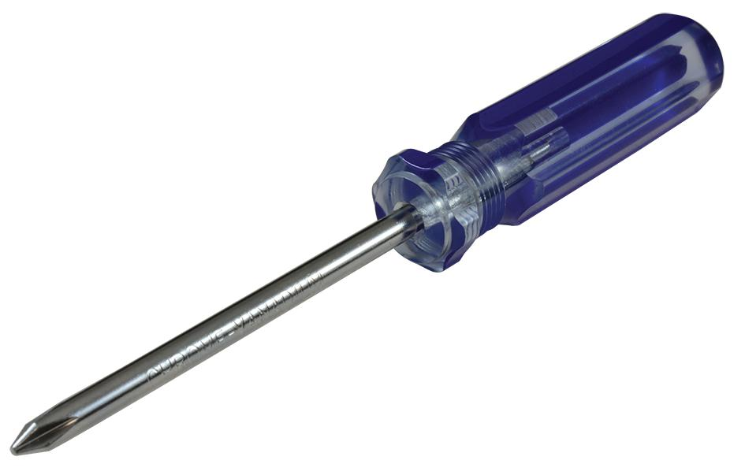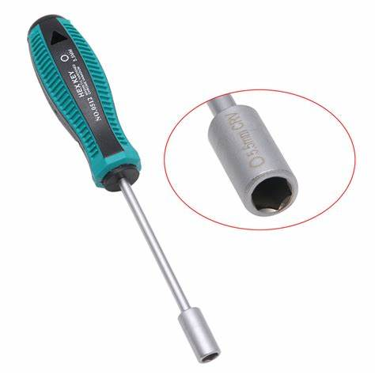
4
3
2
1
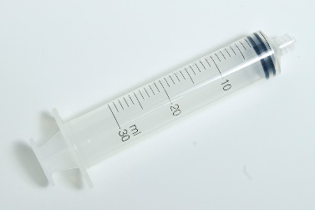
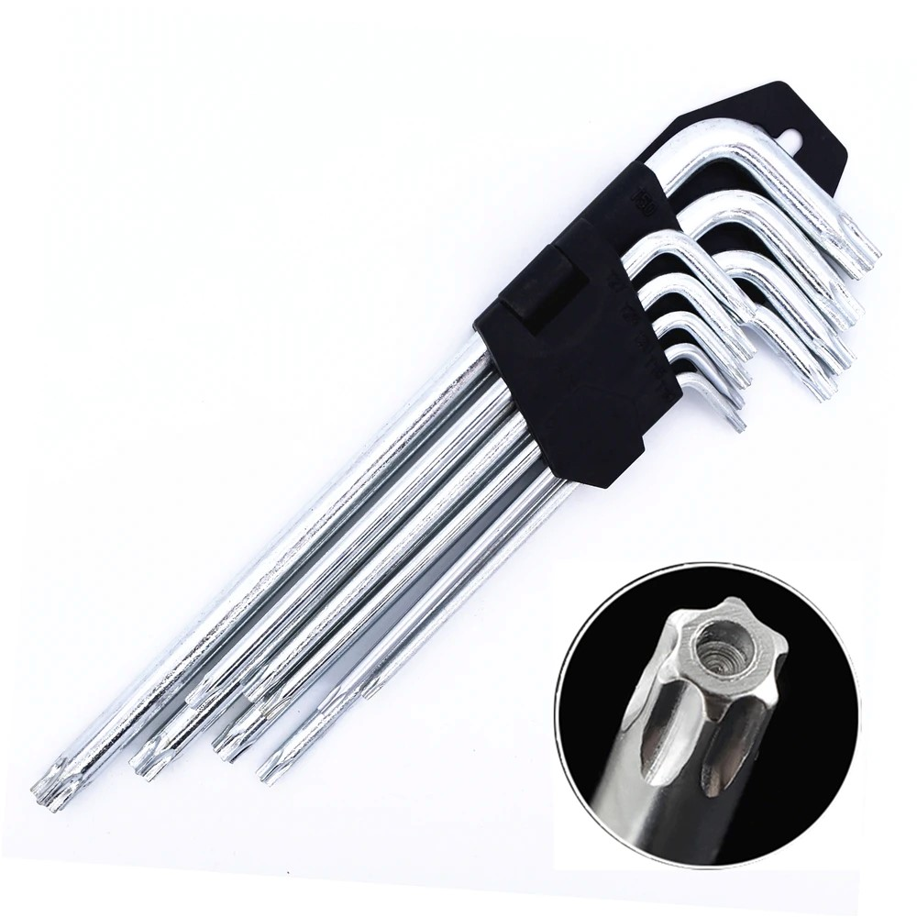
6
5

Special Processes
- Bonding (Refer Doc no. – F-PR-29, REV. 00)
- Conformal (Refer Doc no. – F-PR-12, REV. 00)
- Soldering (Refer Doc no. – F-PR-12A, REV. 00)

Base plate assembly

Grommet Fitting

- Fix the grommet (140.0996.00) in the base plate hole from the outside of base plate (260.2273.00).
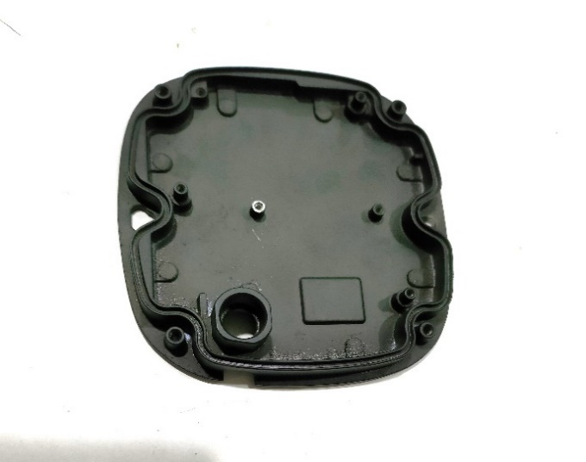
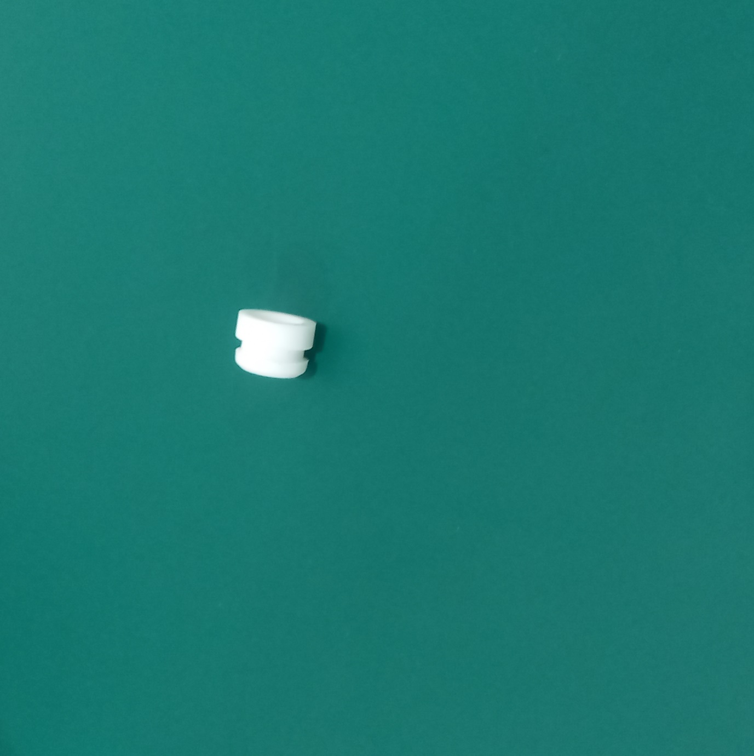
- After the self-test OK, proceed for the next step.

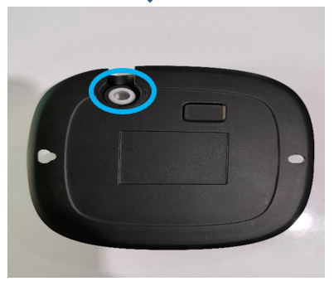

Cable Preparation

- Peel off the POE Cable (01.01.11042_B) to 50mm(approx.).
- Make sure the total cable length should be 450 mm.
- After the continuity-test OK, proceed for the next step.

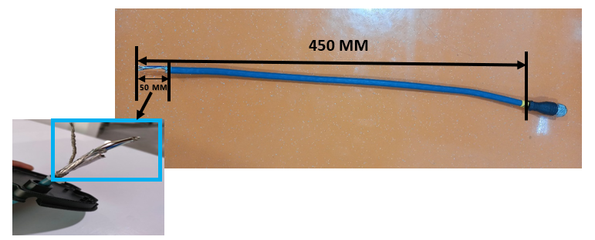

Cable fitment in base plate

- Insert the POE cable through the grommet from the outside of the base plate.
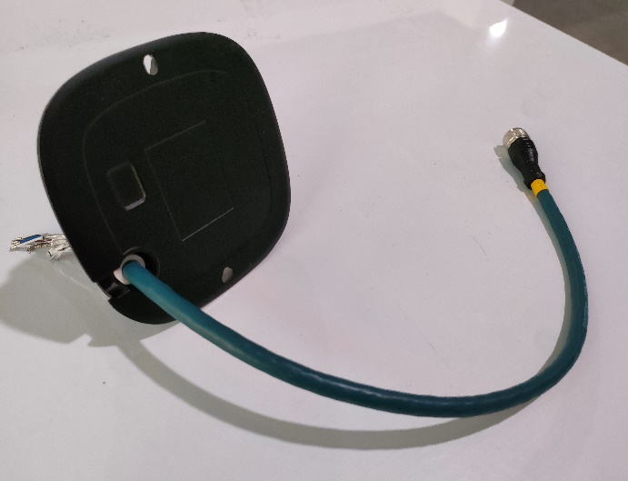
- After the self-test OK, proceed for the next step.

Note: Pay attention to the handling and placement, and ensure that there are no scratches, peeling paint, damage or other undesirable phenomena on the appearance of the material.

- Tight the cable tie (01.01.10598) (minimum size possible) around the POE cable from the inside of base plate of camera. Ensure that same works as a stopper for the POE cable to stay inserted in the base plate.
- After the self-test OK, proceed for the next step.
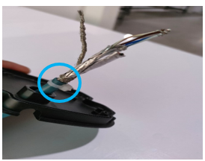
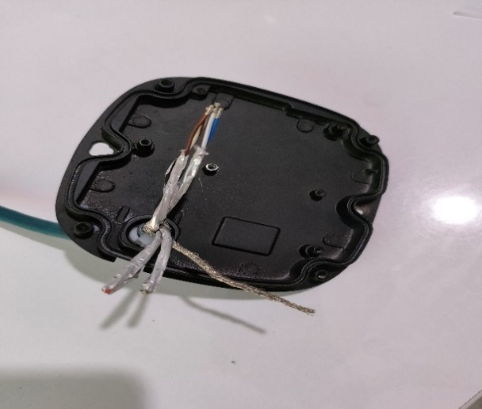

Prepare a shield wire
- Put the sleeve on shield wire of POE cable and then crimp the M2.5 lug (26.71.0205) on the cable shield wire by soldering the same.
- Sleeve should cover the M2.5 lug as shown in the below picture.
- After the self-test OK, proceed for the next step.
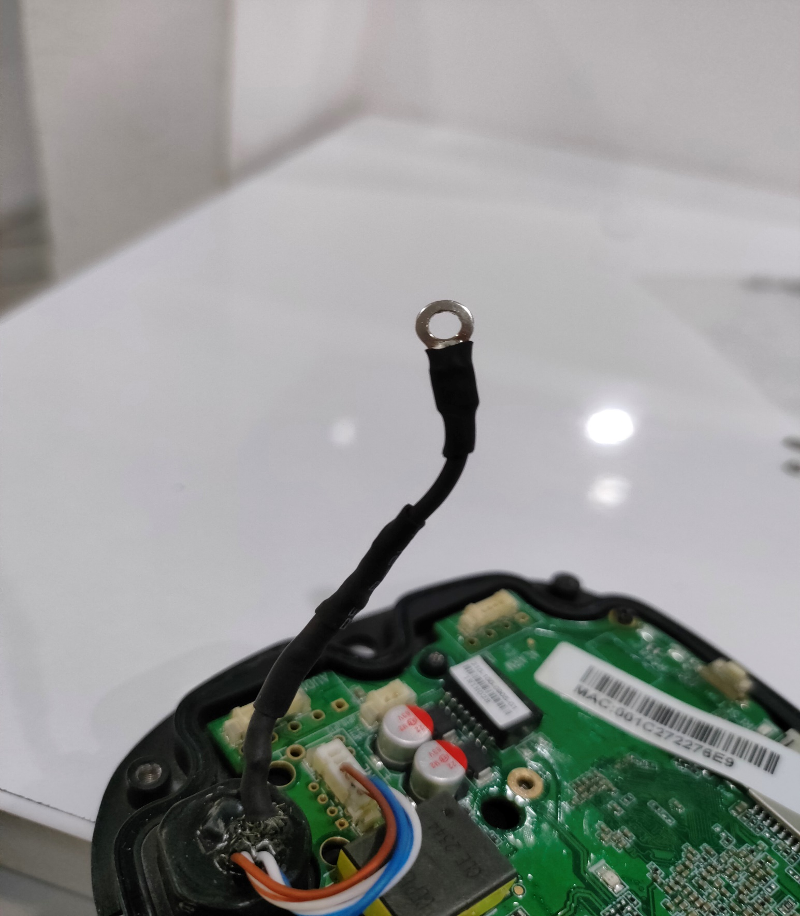

Fix the sealing ring

- Put the JY-D09 sealing ring (140.0918.00) with the flat surface upward and fix it into the groove of the base plate.
- After the self-test OK, proceed for the next step.
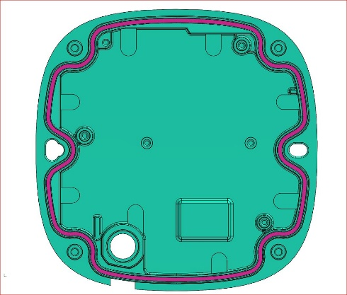
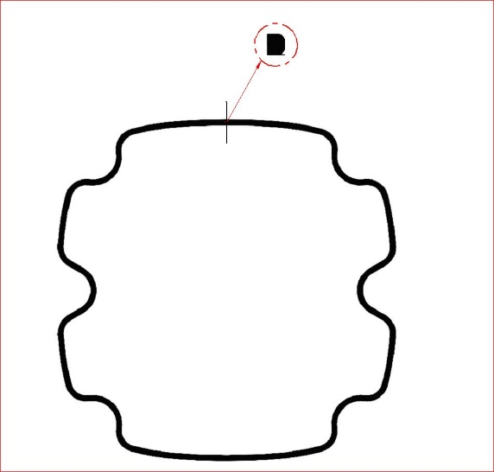

Epoxy process

- To prepare Epoxy EER6003K05K*2 (100436-2), mix the resin (EER6003K5K-A) and hardener (EER6003K5K-B) in proper ratio as defined in data sheet.
- For detailed instructions of how to mix the same please refer the bonding process document (Refer Doc no. -PTC/WI/03, Rev no.- 00).
- Fill the Epoxy EER6003K05K*2 (100436-2) in the epoxy tank as shown in the picture.
- The epoxy cannot be higher than the steps of the epoxy tank.
- After placing the epoxy, it must be placed flat for more than 12 hours.
- Let it be dry till the rock-hard solid state.
- After the self-test OK, proceed for the next step.

- Note: The epoxy higher than the epoxy tank step will affect the assembly of the inner shell.

- Note: Shielding strain should not be visible. All shielding strain should be properly cover from sleeve and epoxy.
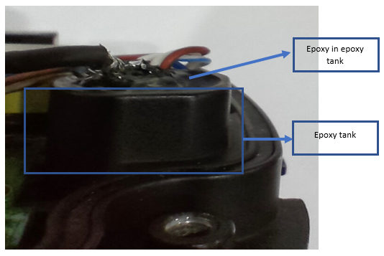

Connection of 6-Pin Data connector

- Insert the POE cable wires in relimate 6 pin female power connector (160.0048.00). For wire designation to their respective pins of the connector please find the table below.

PCB Connector Pin | M12 Connector pin
Pin no. 1 | Pin no. 4
Pin no. 2 | Pin no. 2
Pin no. 3 | Pin no. 3
Pin no. 4 | Pin no. 1
Pin no. 5 | Not in use
Pin no. 6 | Not in use

- After the self-test OK, proceed for the next step.
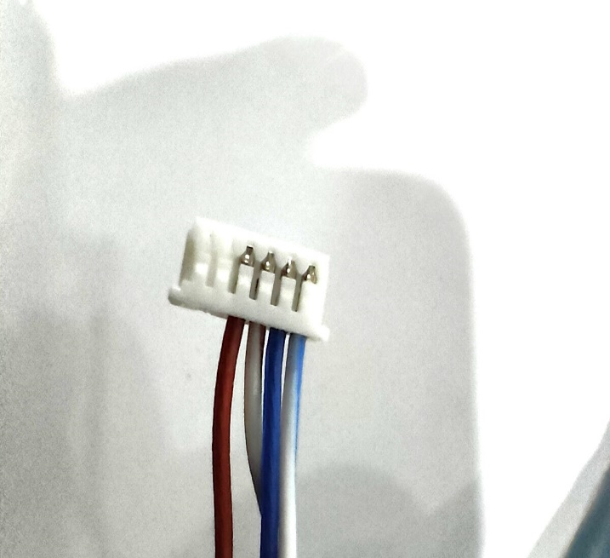

Conformal Instructions

- An electrostatic band must be worn during operation.
- Apply conformal coating on the PCB (33.92.1711) with the help of soft brush.
- Cover all the parts on which conformal coating not applicable.
- For detail instructions please refer the conformal coating document (Refer Doc no. – F-PR-12, Rev no. – 00)
- Let it be dry for 12 Hours.
- After the self-test OK, proceed for the next step.

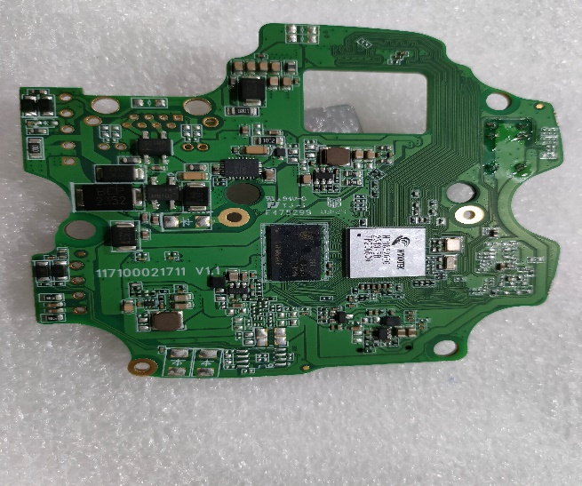
Place thermal conductive sheet

- An electrostatic band must be worn during operation.
- Take 2 PCS thermally conductive silicone sheets 10×10×4mm (140.0581.00) and place them on the motherboard driver chip U7 and chip U6 respectively (Red square)
- Place the thermally conductive silicone sheet 25×25× 4mm (140.0581.00) and place it on the motherboard chip and DDR position (Blue square).
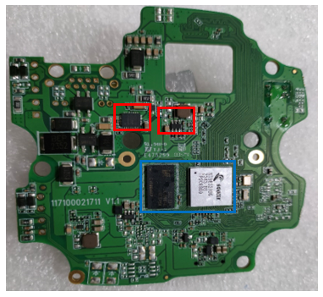
- After the self-test OK, proceed for the next step.

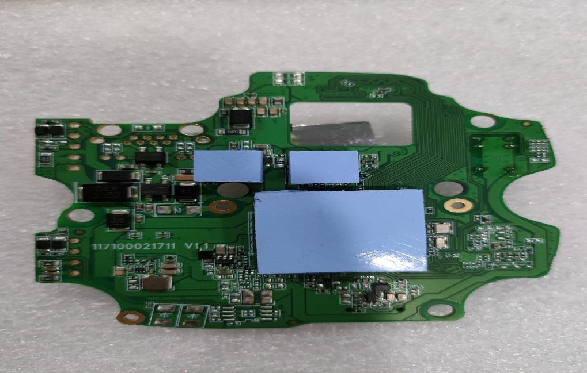

Motherboard PCB fitment

- An electrostatic band must be worn during operation.
- Install the Motherboard PCB (33.92.1711) on the Lower cover housing with help of two PM2×5mm screws (150.1140.00) (Blue circle).
- Screw must not be missed, crooked, used incorrectly, loose, or have thread slippage, etc.
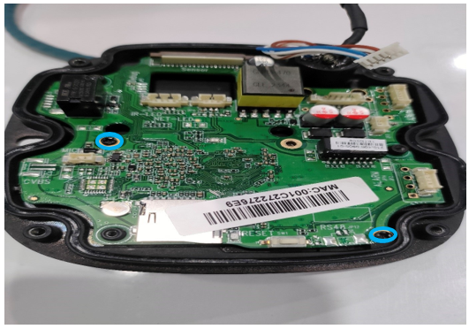
- After the self-test OK, proceed for the next step.

PoE & Shield wire Connections

- An electrostatic band must be worn during operation.
- Insert the PoE cable 6 pin connector into the LANE port (Red square) of the motherboard PCB.
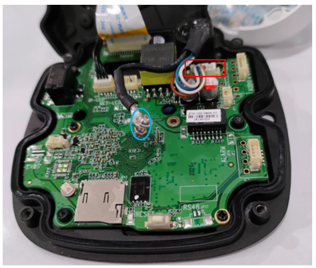
- Wire M2.5 lug (26.71.0205) should be placed between M2 plan washer (26.96.0202) and M2 nut (26.92.0202) (Blue circle). For reference look at the picture below.

- Shielded wire M2.5 lug (26.71.0205) should be tightened with a one M2×5mm pan head screw (26.84.0205), M2 nut (26.92.0202) and M2 plan washer (26.96.0202) on PCB.
- Screw must not be missed, crooked, used incorrectly, loose, or have thread slippage, etc.
- Make sure the M2.5 lug (26.71.0205) should not be touched to PCB (Red circle).

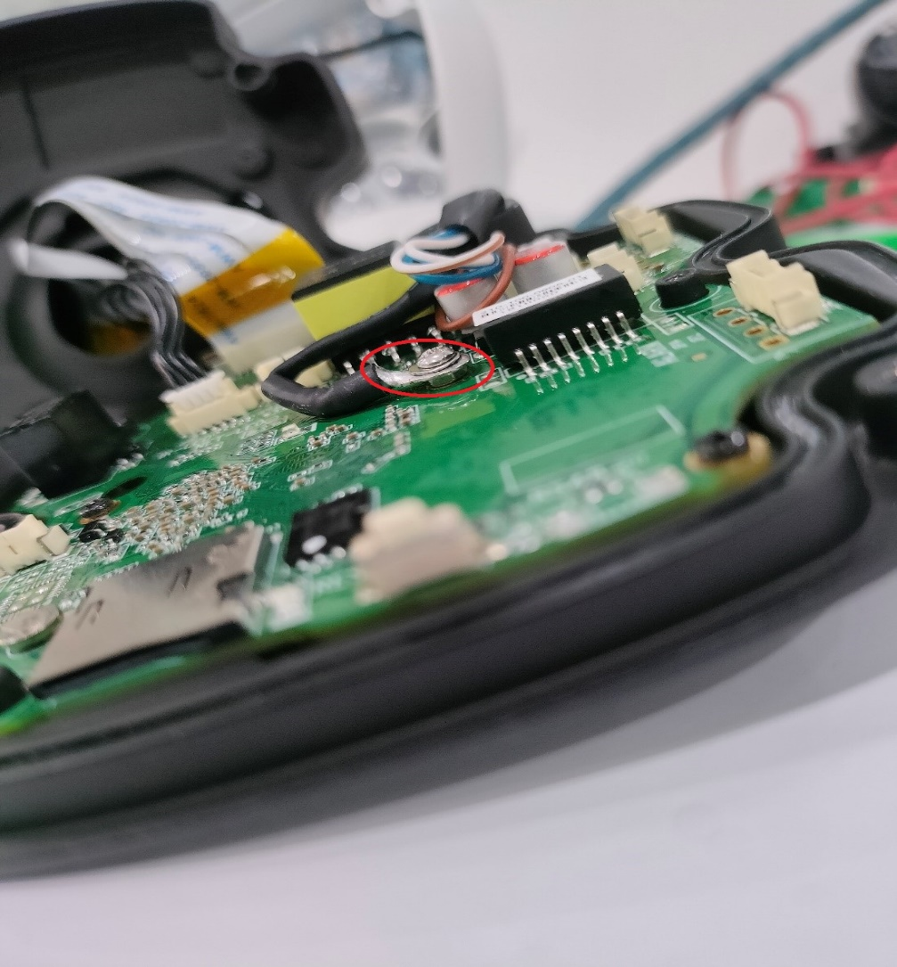

Middle/Internal assembly

Lens Ball assembly (260.2274.00)

- An electrostatic band must be worn during operation.
- Insert the lens ball into the lens ball holder from the bottom side of the lens ball holder such that the 180 degree mark matches (Blue circle) with the mark(I) of lens ball holder at the upper side of the same.
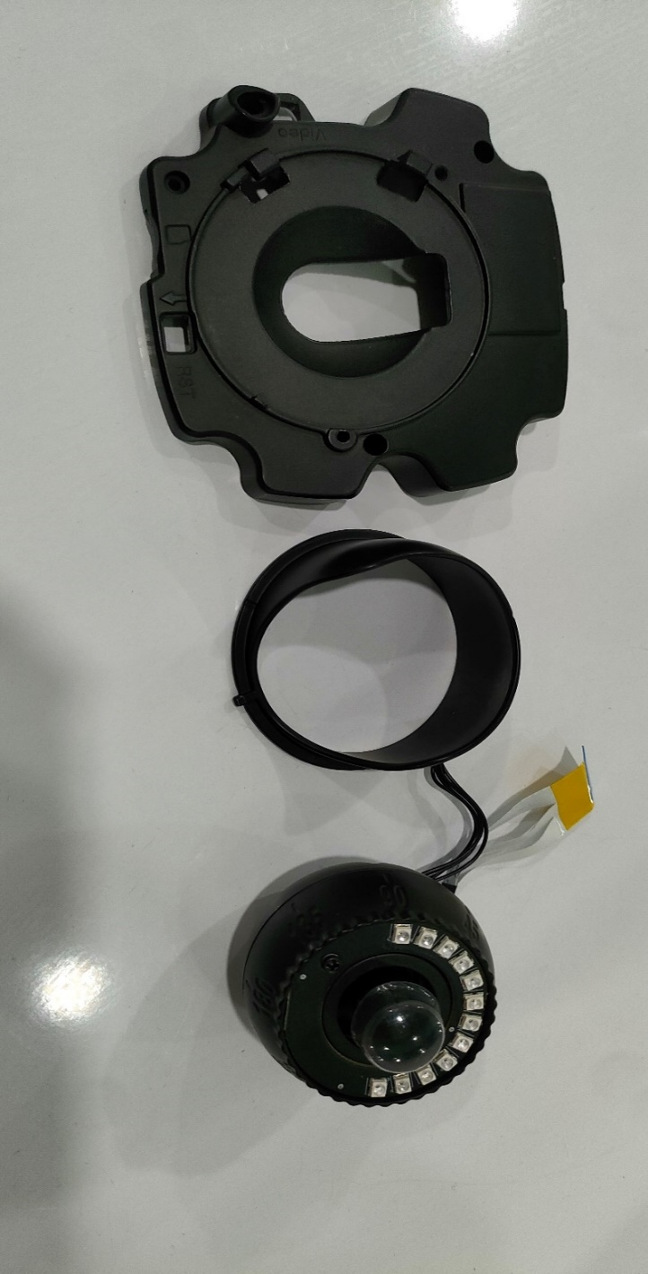
- After the self-test OK, proceed for the next step.

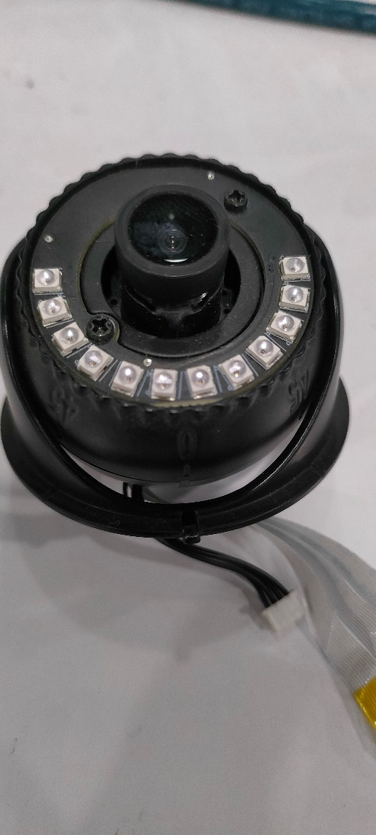
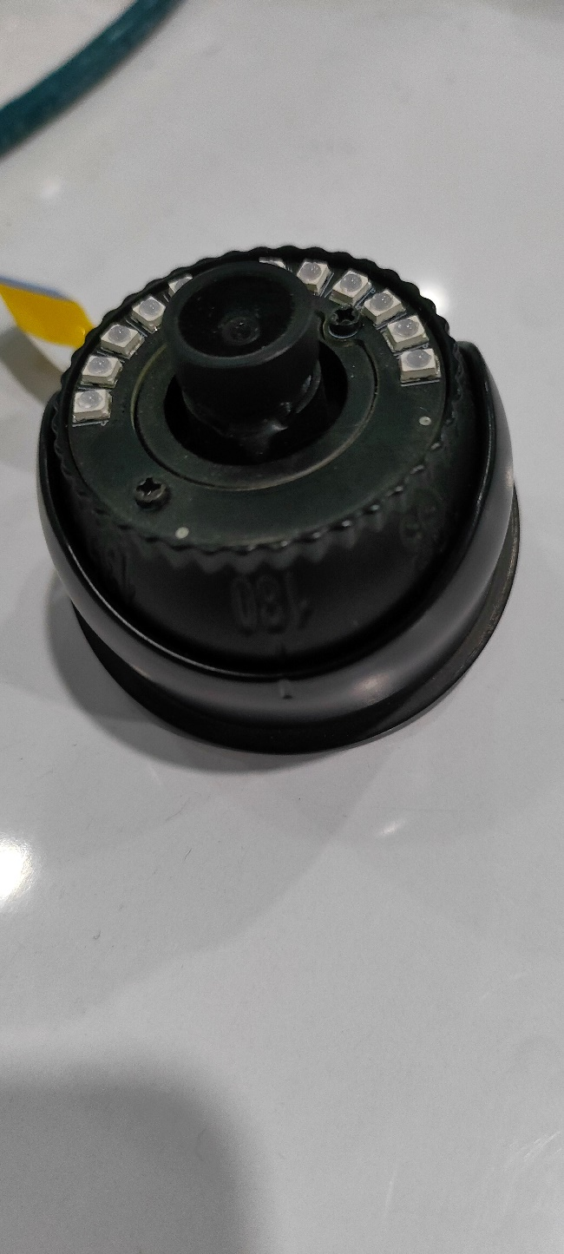

Microphone (165.0009.00) assembly (For with Mic cameras only)

- Remove the rubber cover from the microphone and insert the microphone through the hole of inner shell cover (260.2272.00) from bottom side (Blue circle).
- After the self-test OK, proceed for the next step.
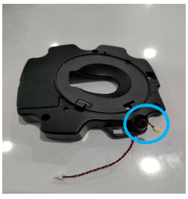
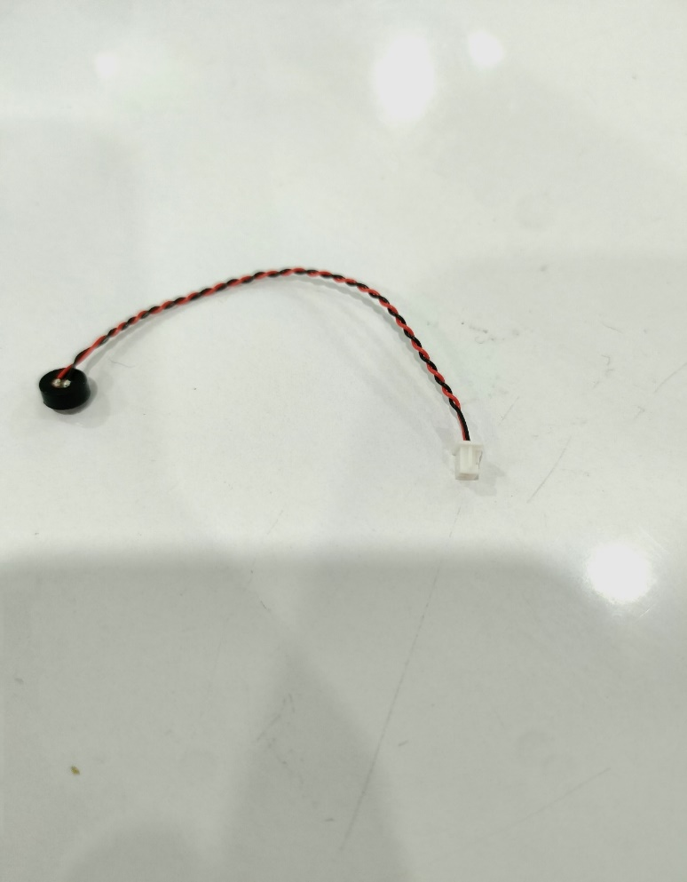

- Place the rubber cover back on the microphone.
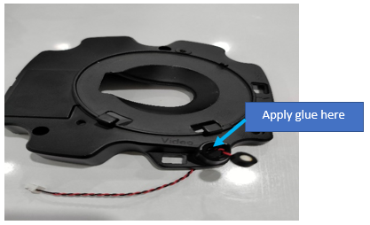
- Apply Silicon glue on the internal circumference of the hole. For reference look at the picture below.

- Then pull the microphone gently towards the hole such that it fixes properly on its respective hole.
- After placing the microphone on the glued area, it must be placed flat for more than 1 hours.
- After the self-test OK, proceed for the next step.

- Note: There should be no glue on the microphone otherwise it results the malfunction of microphone.

Inner shell assembly

Lens ball assembly and inner shell cover fitment

- An electrostatic band must be worn during operation.
- Pass the FFC sensor and LED cable gently through the hole of inner shell cover (260.2272.00).
- After the self-test OK, proceed for the next step.

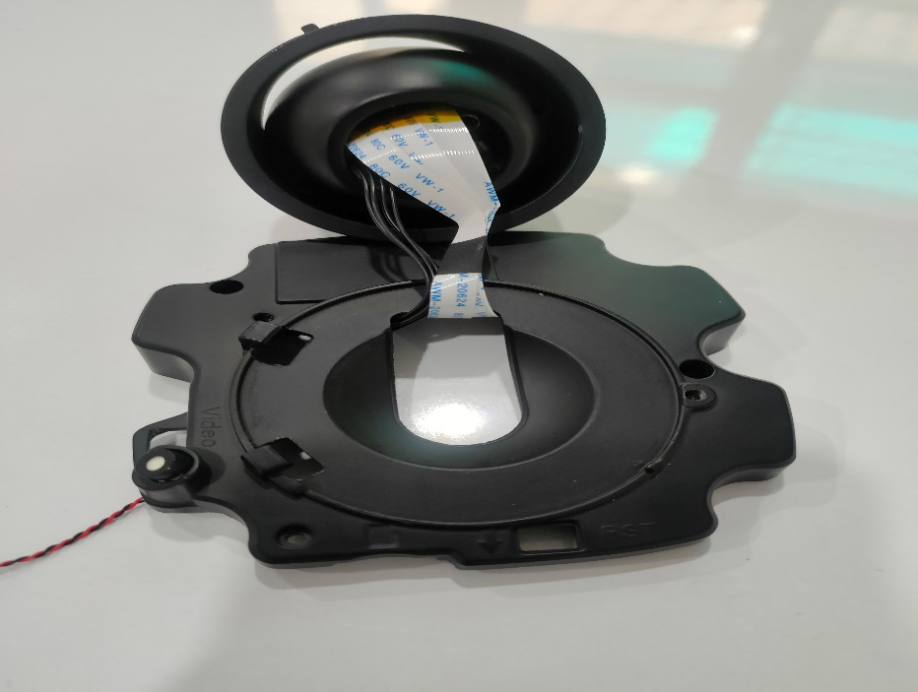

- Place the lens ball assembly onto the inner shell cover such that lens ball mark (I) matches with the mark of inner shell cover (Blue circle).
- After the self-test OK, proceed for the next step.
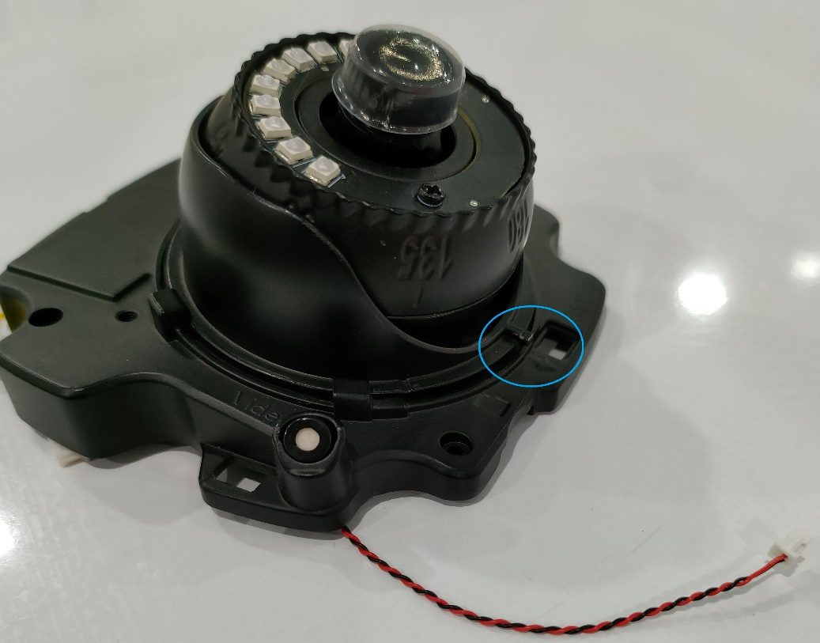

- Lock the lens ball assembly with the inner shell cover with the help of one PWM3×6mm type screw, spring washer and plain washer (150.1137.00) (Blue cover), it results the locking of three components altogether (lens ball, lens ball holder and inner shell cover).
- Screw must not be missed, crooked, used incorrectly, loose, or have thread slippage, etc.
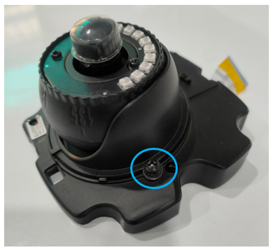
- After the self-test OK, proceed for the next step.

Safety Rope and Desiccant

- Lock the safety rope to designated hole (yellow circle) with the help of one (PW3×4.5mm) screw (150.1117.00).
- Safety rope to be lock from the upper side of inner shell cover as shown in picture.
- Attach the carbon-oxygen desiccant (140.0613.00) to the designated position (Blue square) on the top cover (260.2271.00) as shown in the picture.
- Screw must not be missed, crooked, used incorrectly, loose, or have thread slippage, etc.
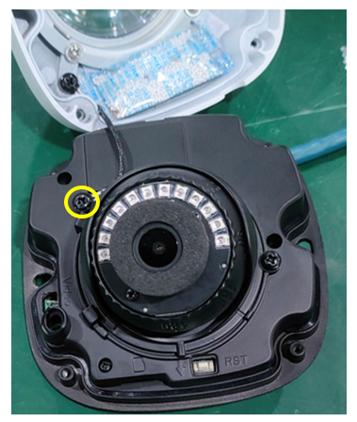
- After the self-test OK, proceed for the next step.

Wiring Connection’s Description

- An electrostatic band must be worn during operation.
- Insert the LED cable 4 pin connector into the JP-10 port of the motherboard PCB (Green square).
- Insert the 36PIN/FFC sensor cable into the JP-8 port of the motherboard PCB (Blue square).
- Pins of FFC sensor cable should be towards the motherboard PCB side.
- Do not buckle at an angle.
- The buckles on both sides of the socket need to be clicked. And glue reinforcement is to be there.
- Insert the Microphone 2 pin connector into the JP-9 port (Red square) of the motherboard PCB. (With Mic Camera Only)
- Apply Glue (Silicon RTV) on the connectors to ensure that connectors will not get loose during operation.
- After the self-test OK, proceed for the next step.
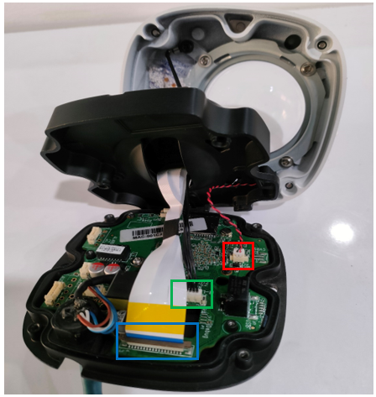

Fitment of Middle/Inner Assembly

- An electrostatic band must be worn during operation.
- Mount the Middle/inner assembly on the base plate with the help of three PM2×5mm screws (150.1140.00) (Blue circle).
- Ensure that the reset button should be set to the designated hole (Red Square). As shown in figure.
- Screw must not be missed, crooked, used incorrectly, loose, or have thread slippage, etc.
- After the self-test OK, proceed for the next step.
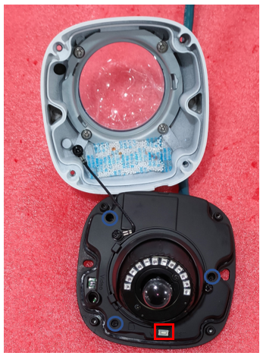

- Remove the plastic lens protection cover from the lens.
- Use an air gun to blow off the dust on the lens. If there is any dirt, wipe it clean with dust-free cloth dipped in alcohol.
- Place the lens protection cover (Cylindrical shading cotton ring) (140.0788.00) onto the lens. (Blue Circle)
- Remove the protective polythene layer from the inner side of glass of top cover.
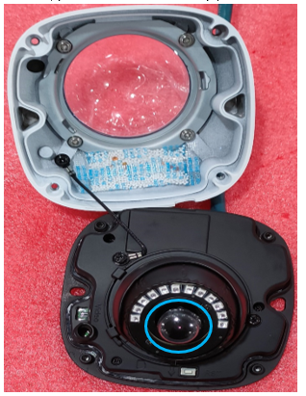
- After the self-test OK, proceed for the next step.

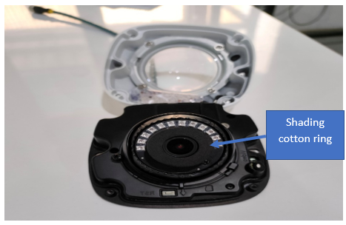

Final Assembly

- Use four PM3×9mm Torx head screws (150.1411.00) (Blue circle) to mount the top cover onto the base plate with the help of Torx Allen key (T10) (150.0402.00), it locks the top cover and base plate together.
- Screws must not be missed, crooked, used incorrectly, loose, or have thread slippage, etc.
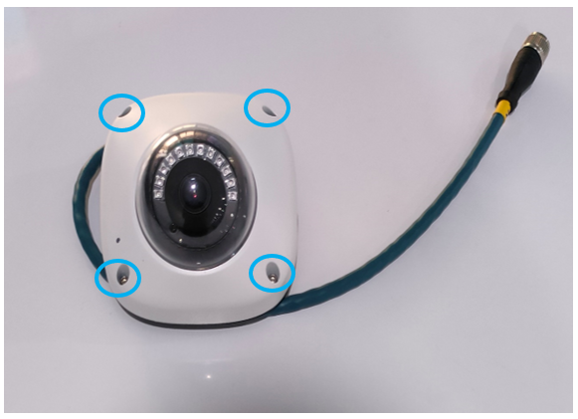
- After the self-test OK, proceed for the next step.

Annexures

- Bonding Process
- Conformal Process
- Soldering Process

End of Document

